Comparative Cognition Protocol:

August 2017

**Individuals**

N=36 Gambusia affinis from BFL Pond 7

Individuals will be run in three rounds, with 3 males and 3 females in each

Individuals will be isolated two days before they start their first day of assays

*ROUND PILOT*

HIGH

Grace - 3.734 cm, 0.97g - Mercury H1

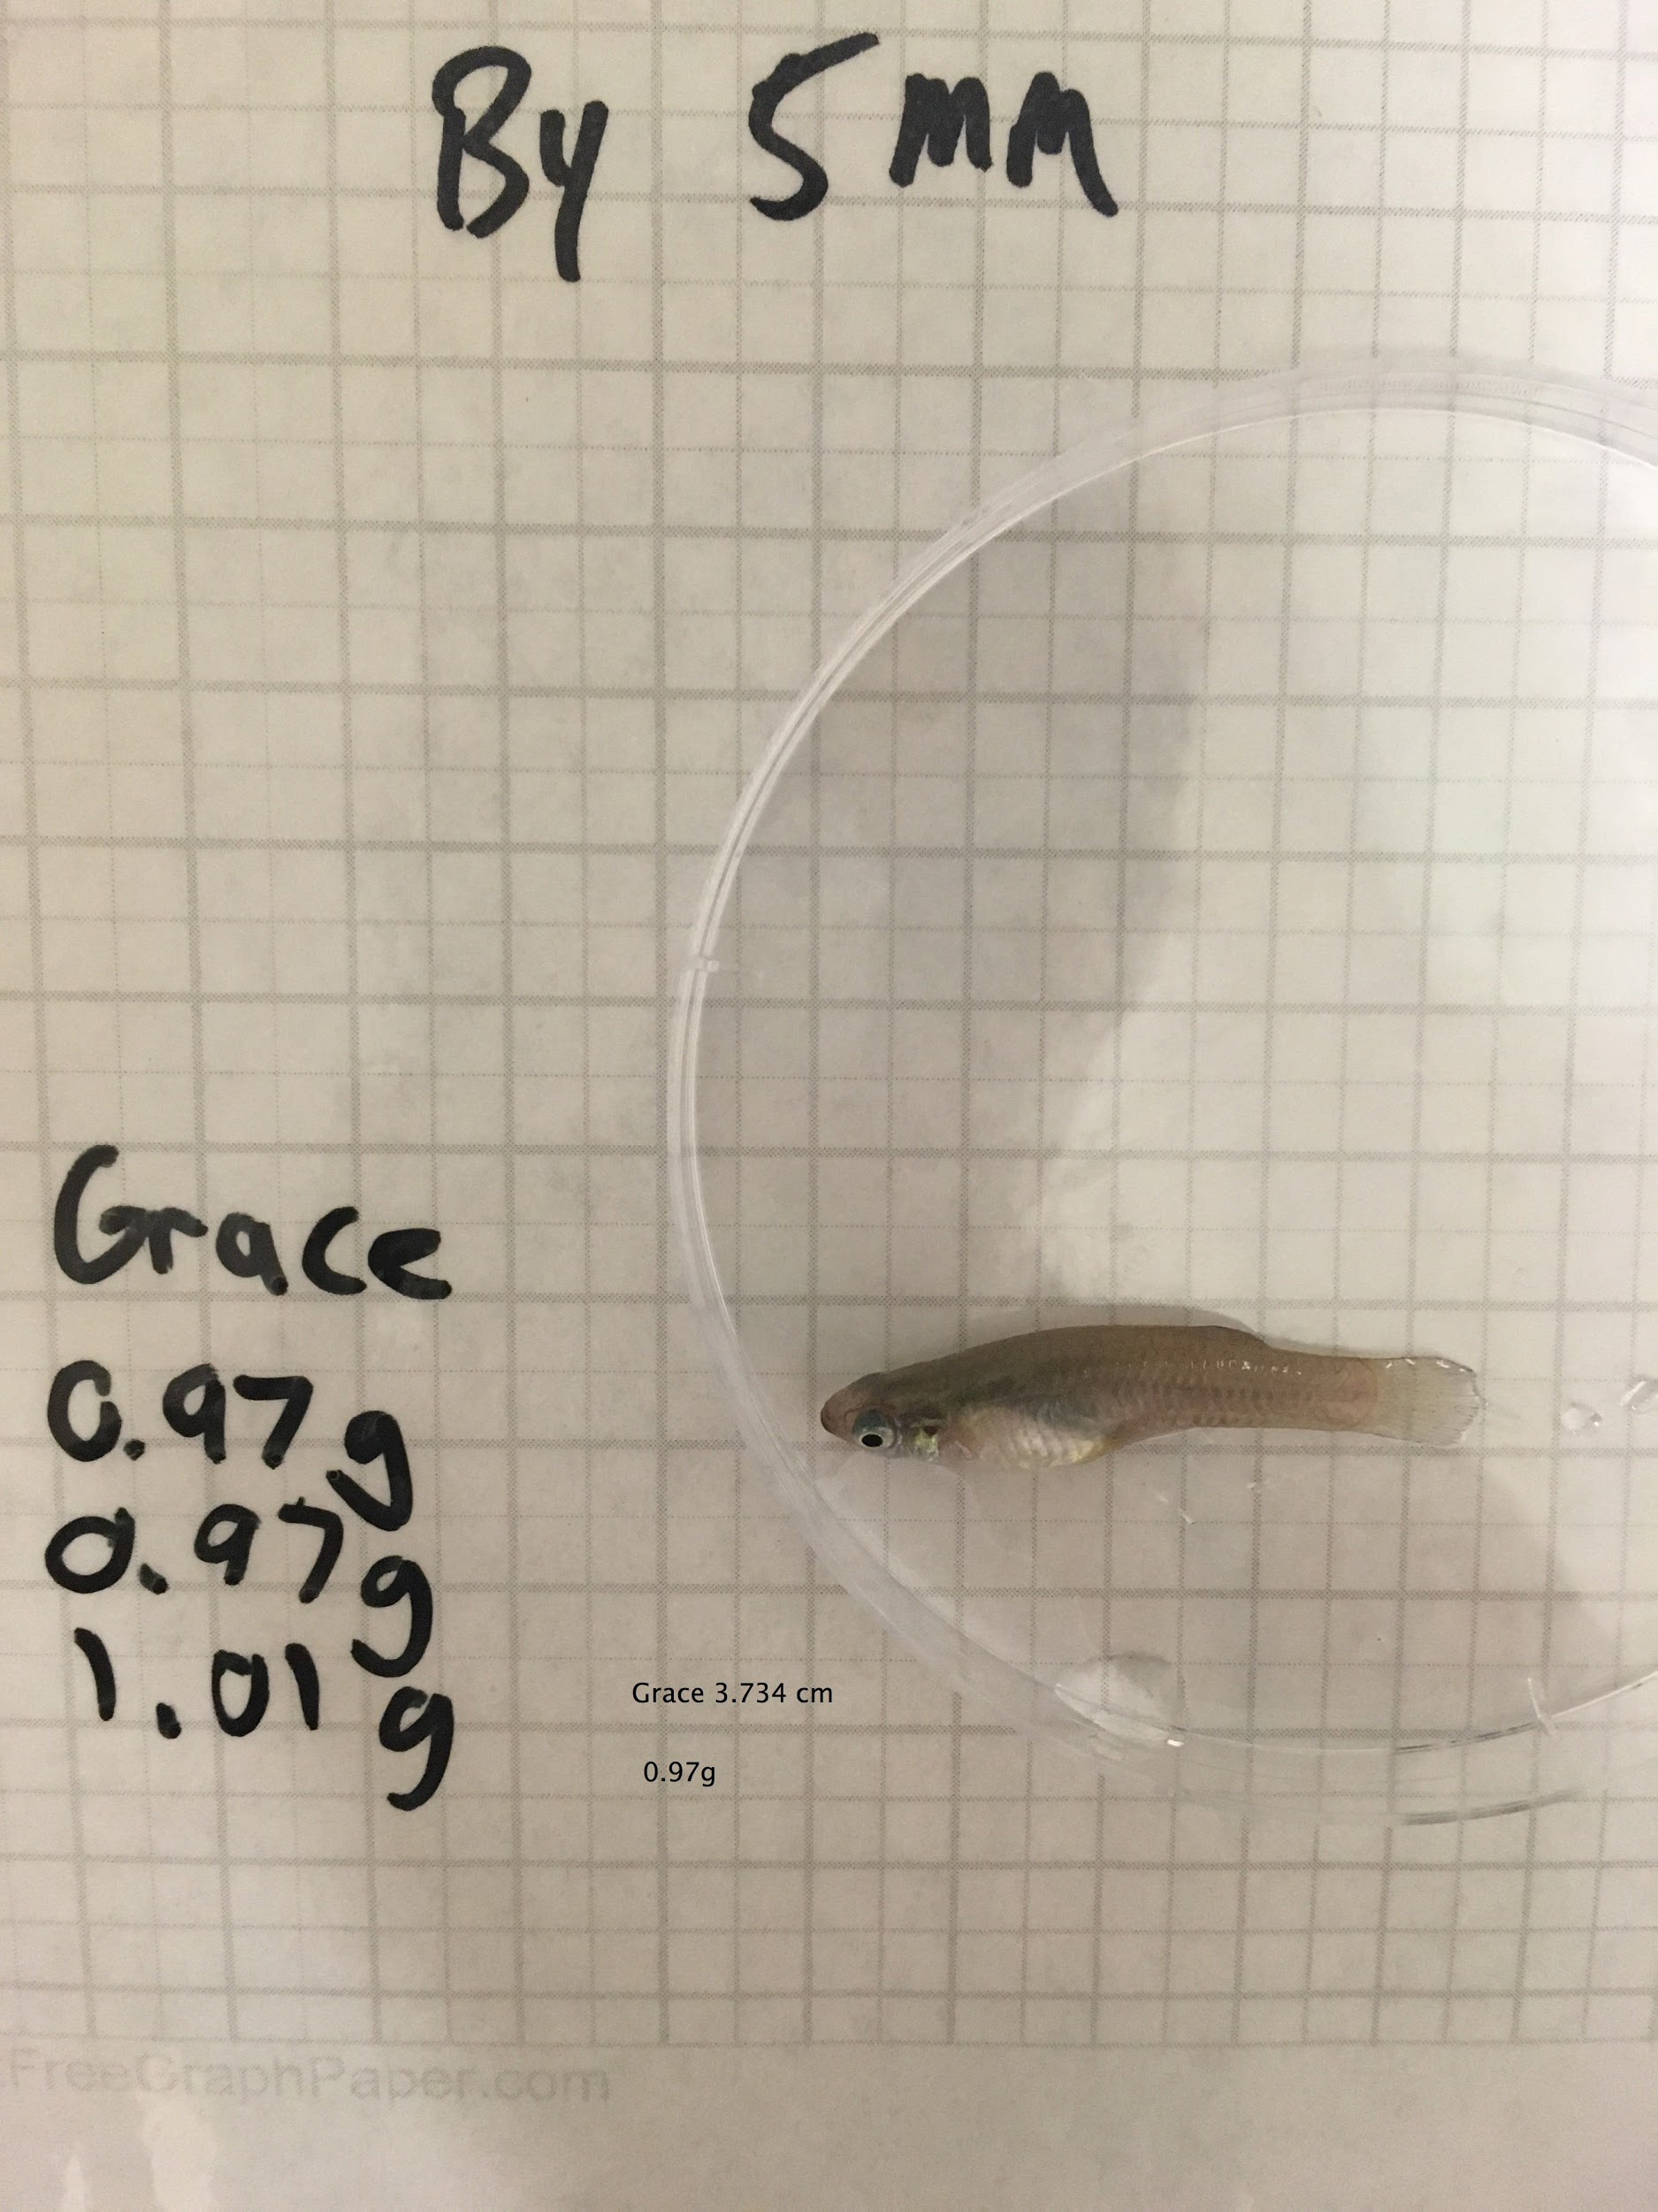

Glinda - 3.758 cm, 1.03g - Earth H2

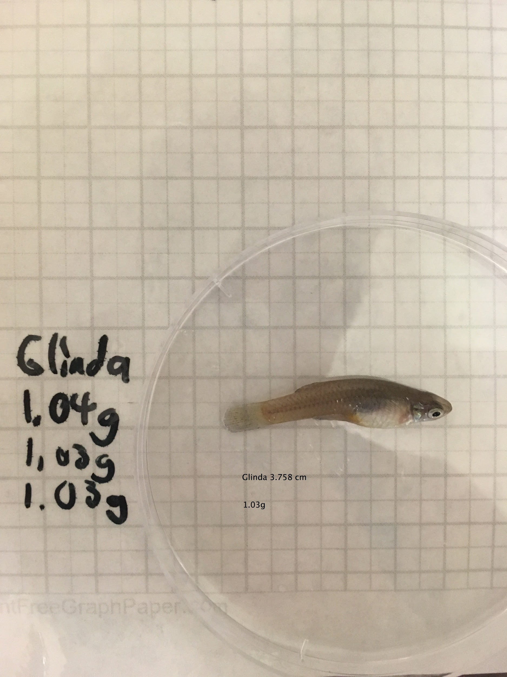

Gregory - 2.339 cm, 0.19g - Jupiter H3

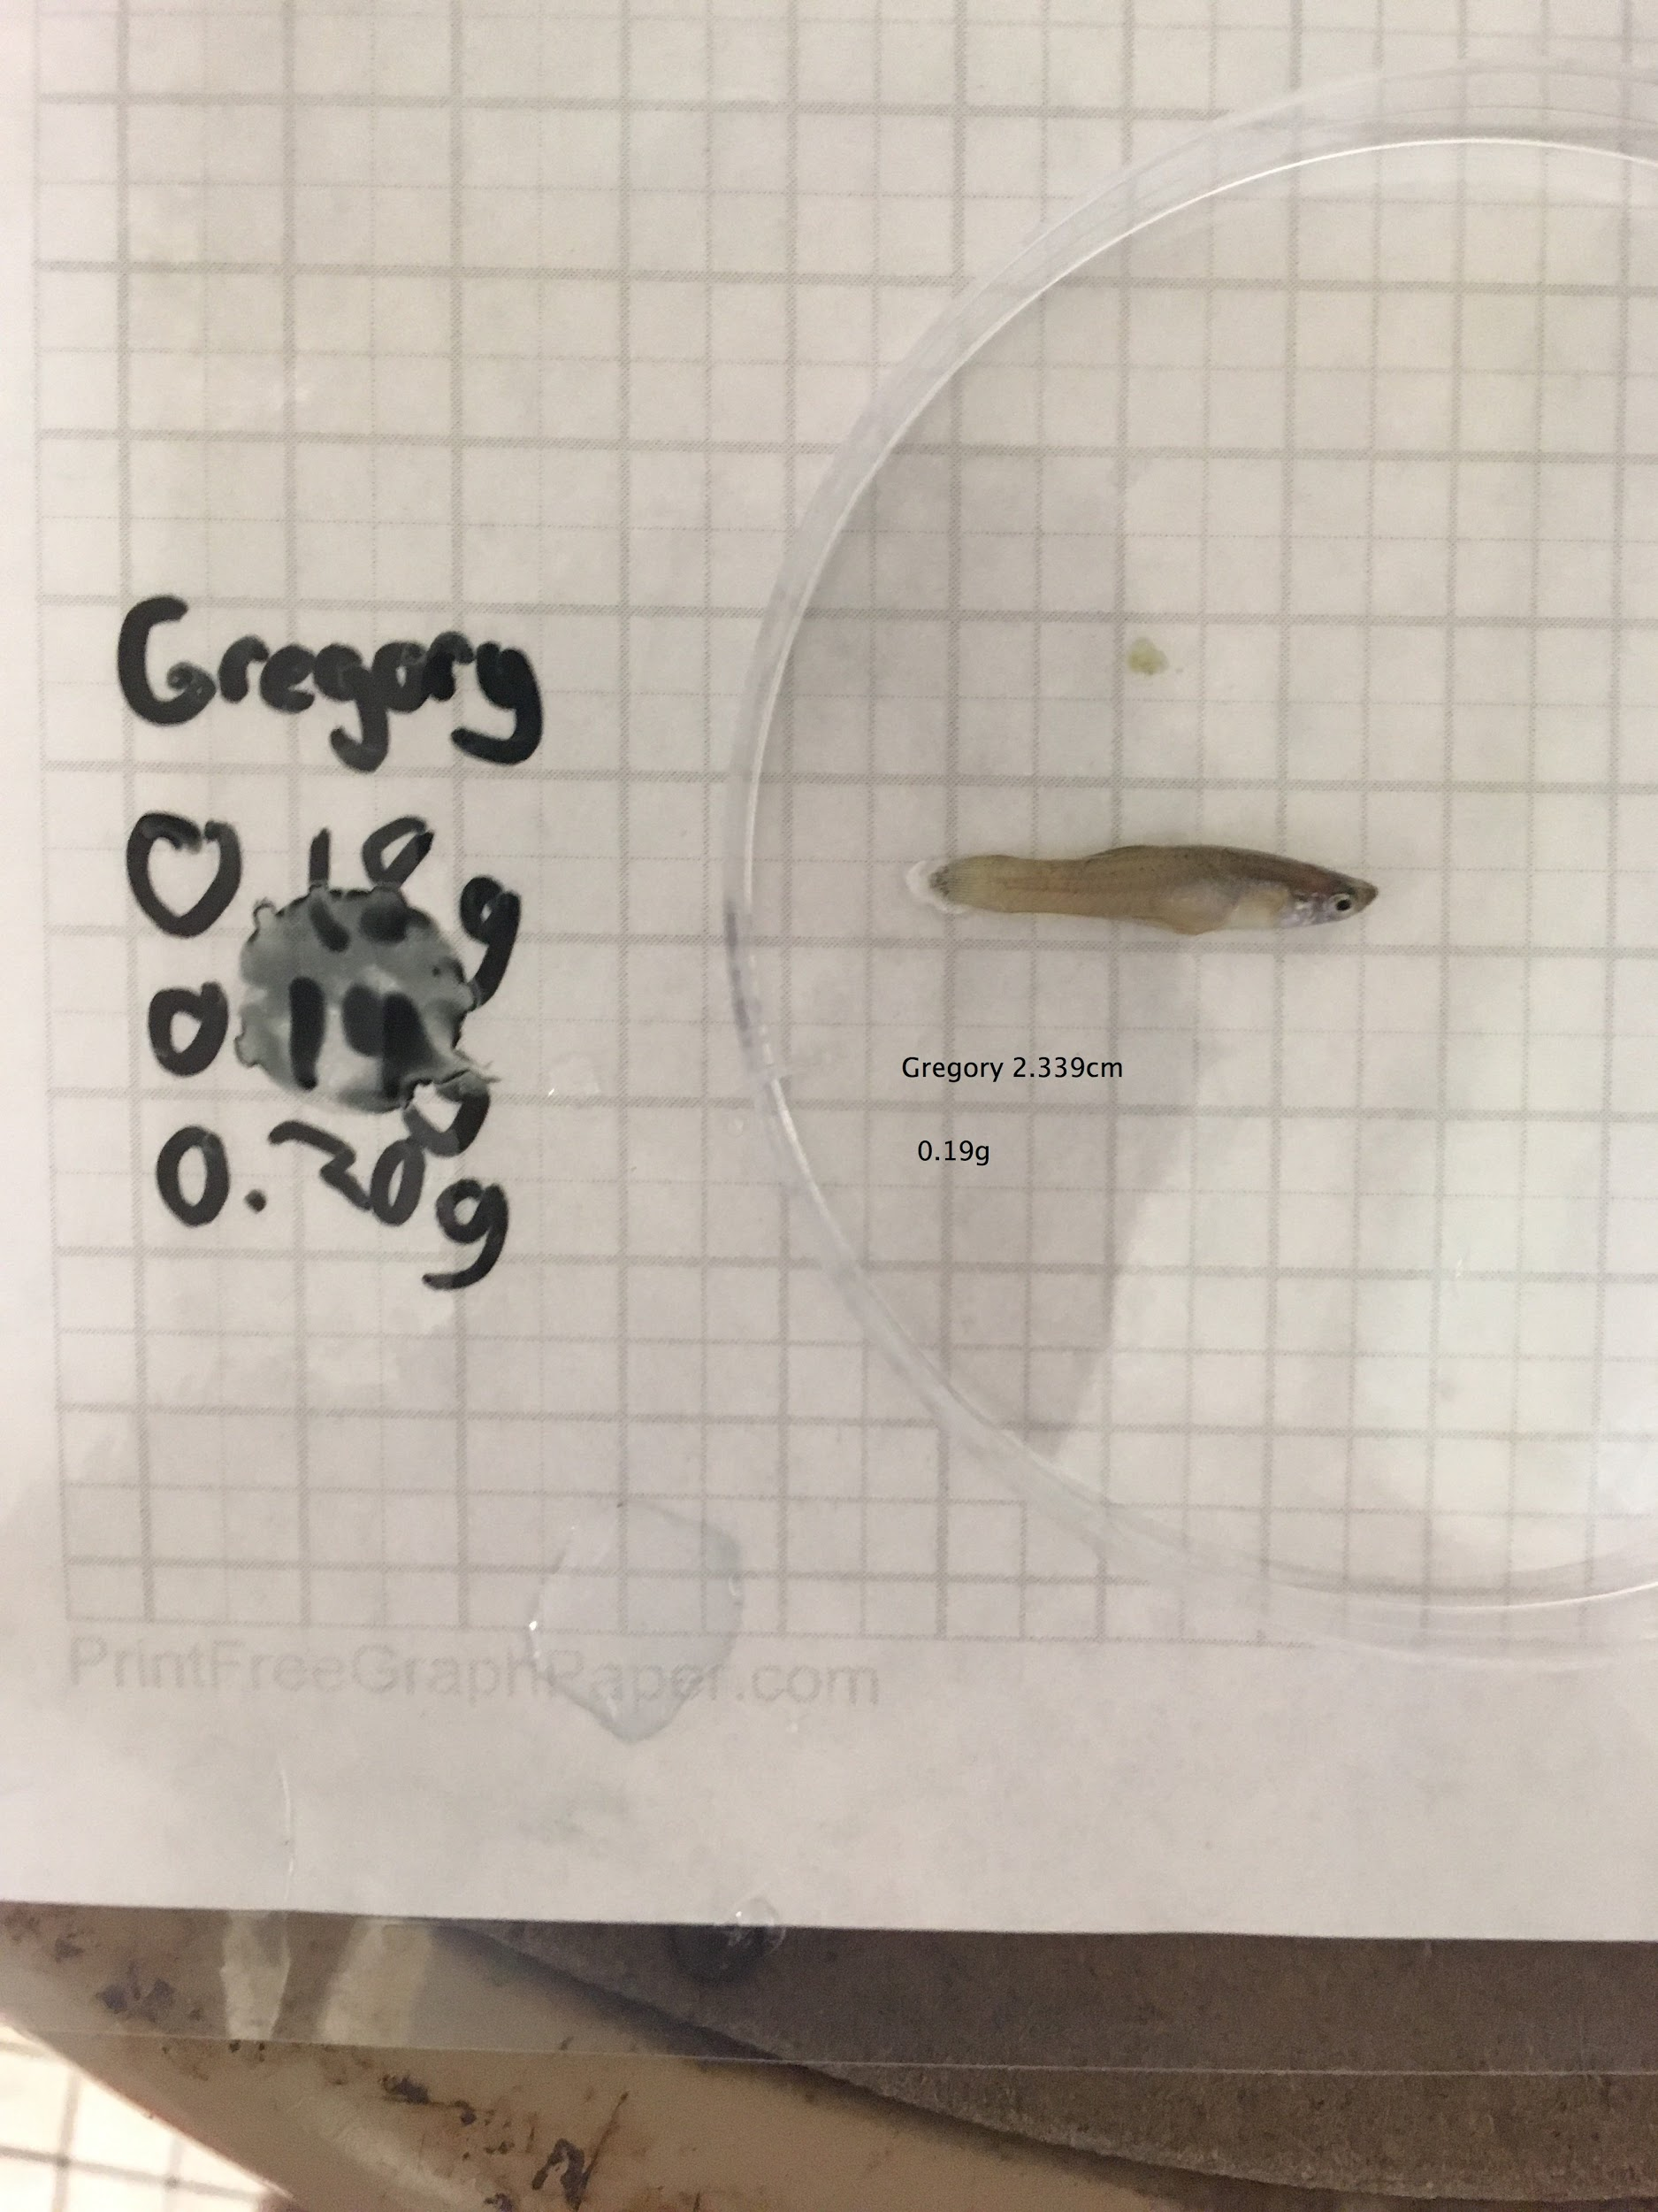

LOW

Walter - 2.003 cm, 0.15g - Uranus L1

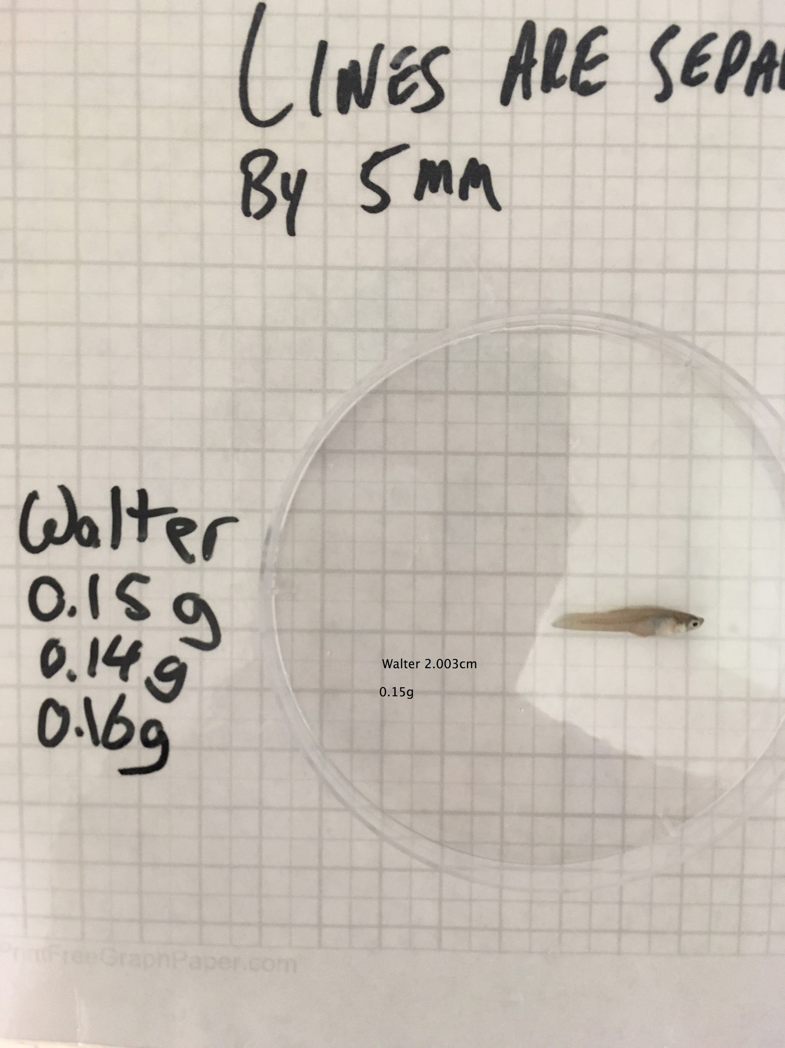

Winston - 2.010 cm, 0.14g - Pluto L2

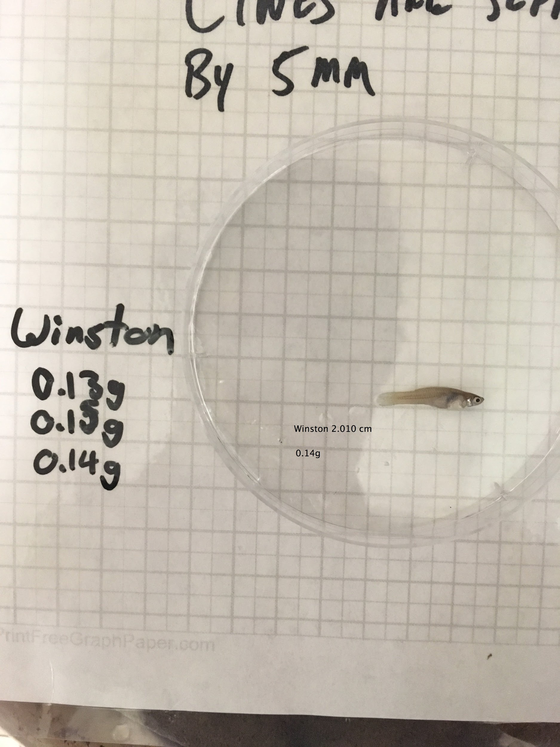

Winnie - 3.549 cm, 0.97g - Haumea L3

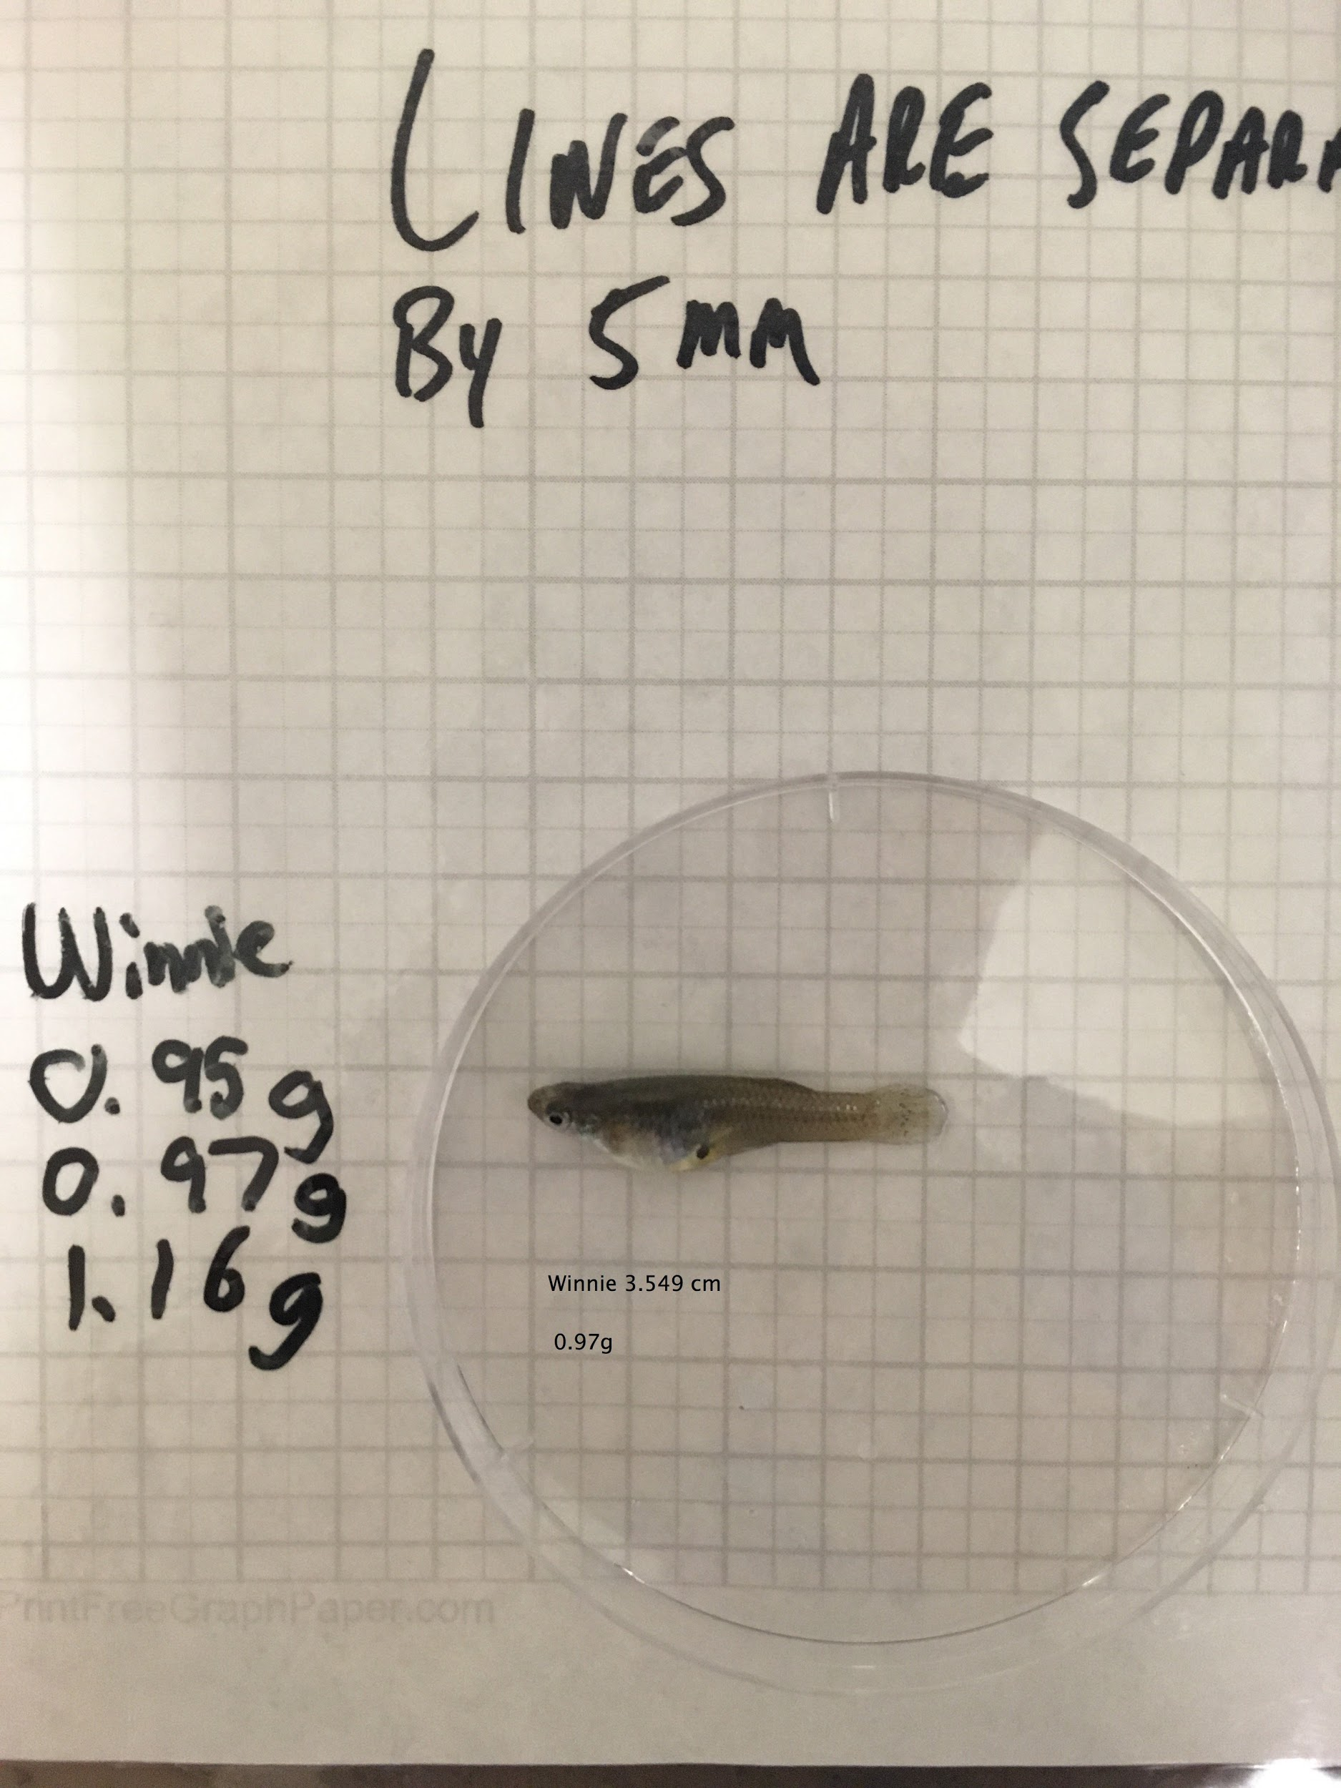

*ROUND CC-1*

HIGH

George - 2.222 cm, 0.14 g

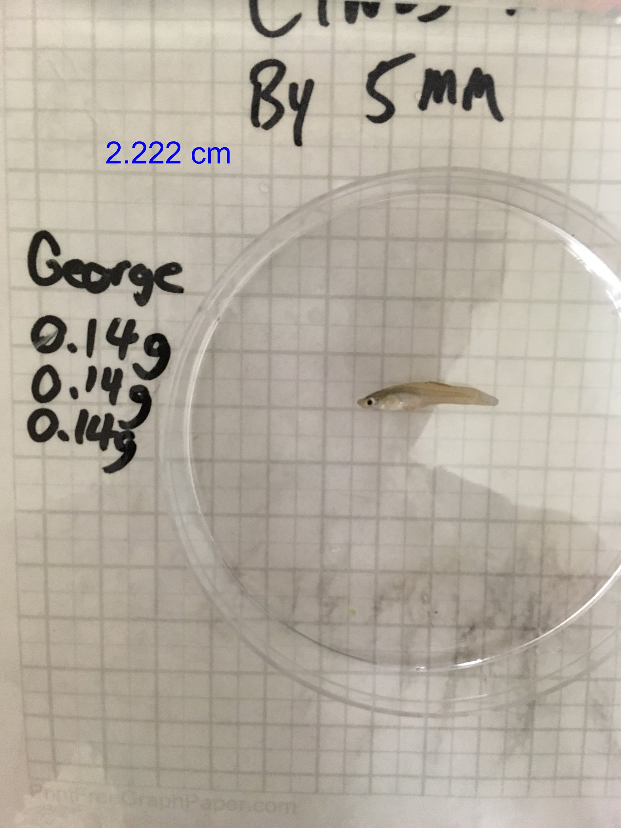

Gary - 2.330 cm, 0.18 g

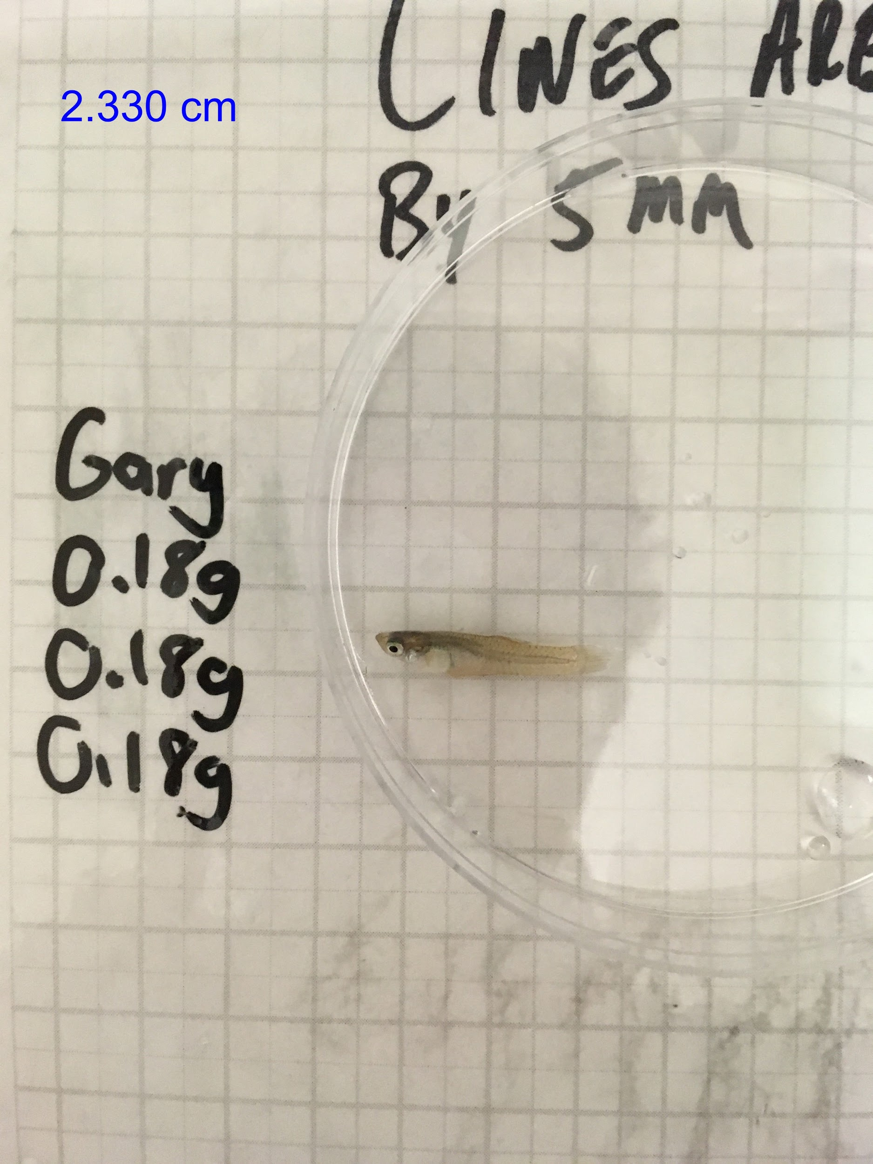

Gail - 3.230 cm, 0.73 g

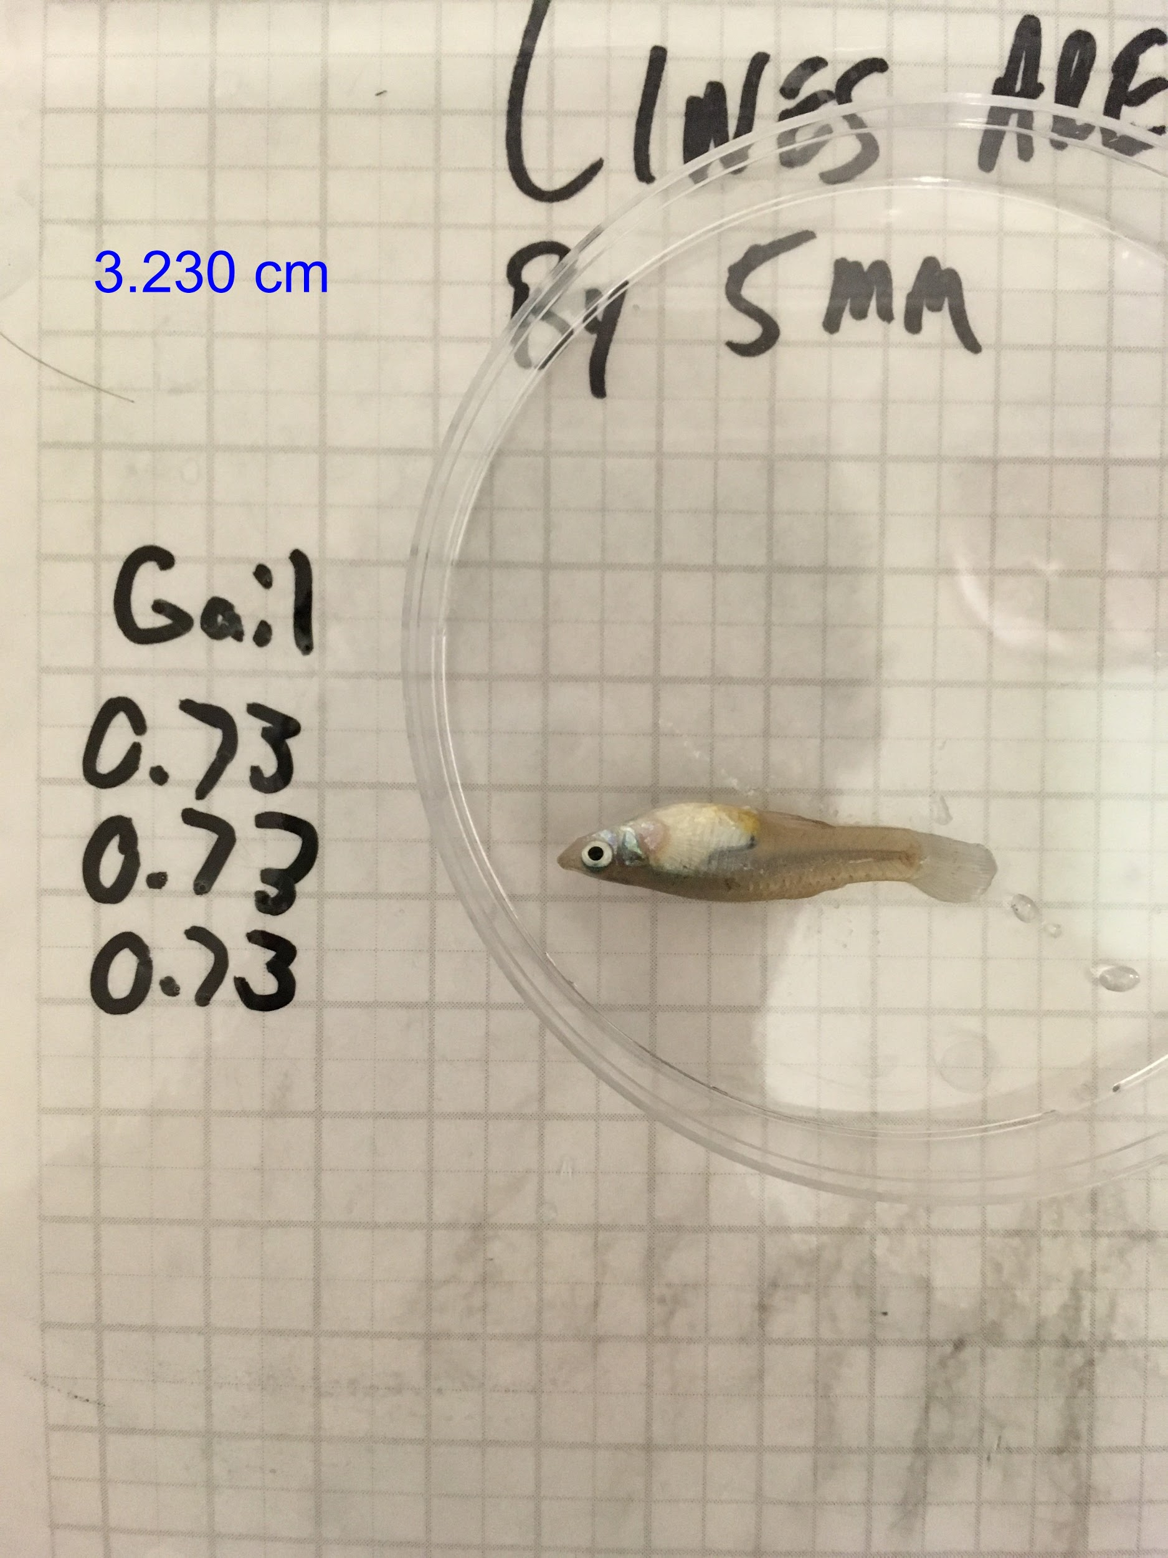

LOW

Wheatley 2.380 cm, 0.13 g

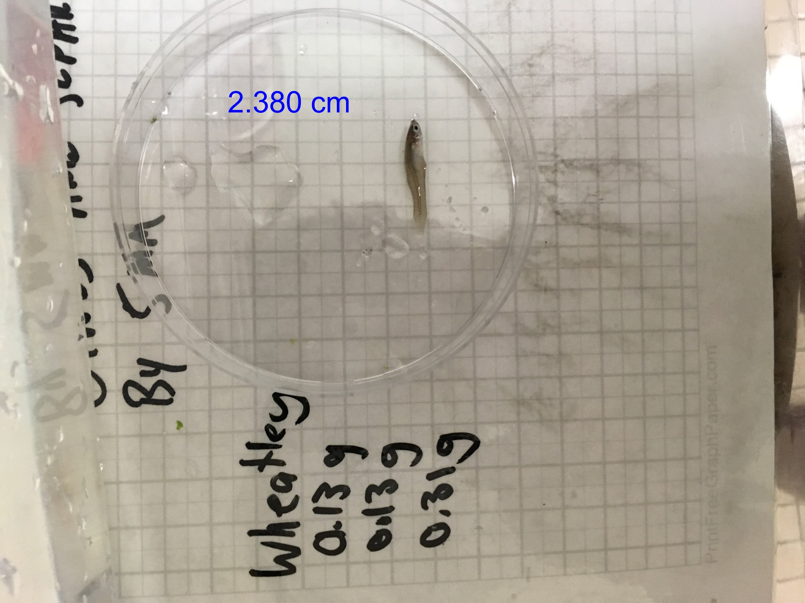

Willow - 2.669 cm, 0.383 g

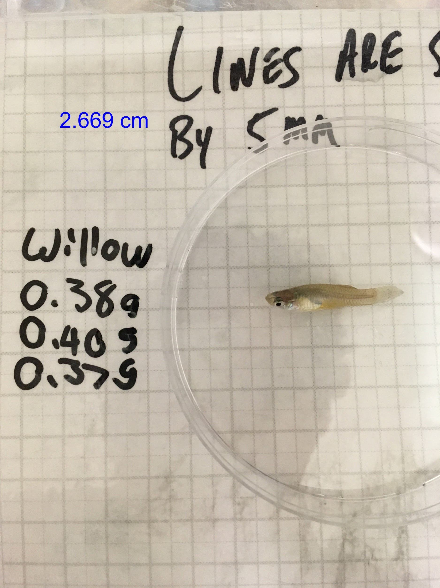

Wendy 3.437 cm, 0.793 g

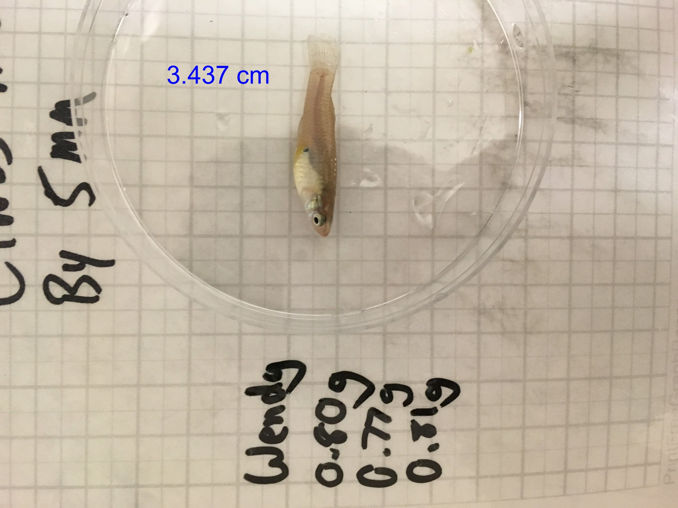

*ROUND CC-2*

HIGH

Gloria 3.350 cm, 0.72 g

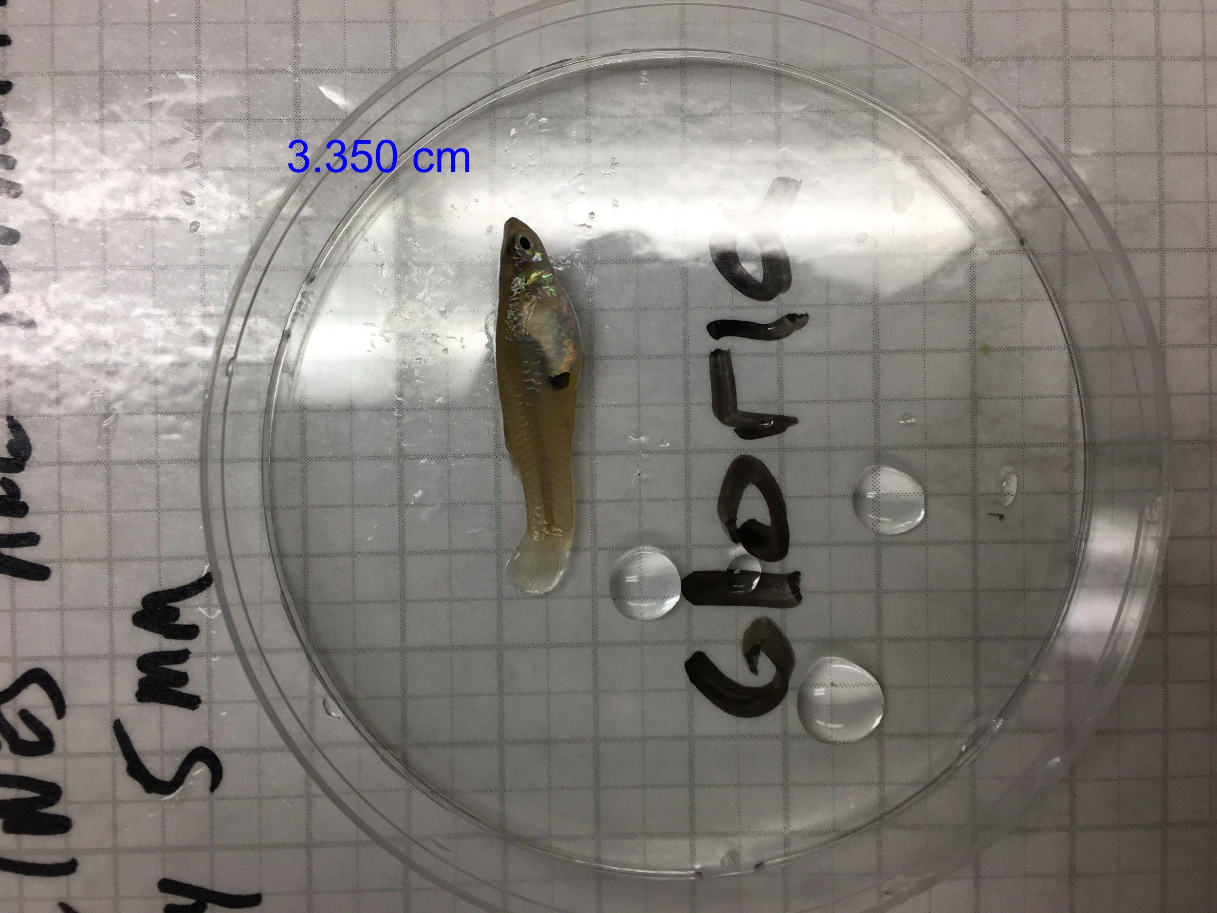

Gertrude 2.878 cm, 0.62 g

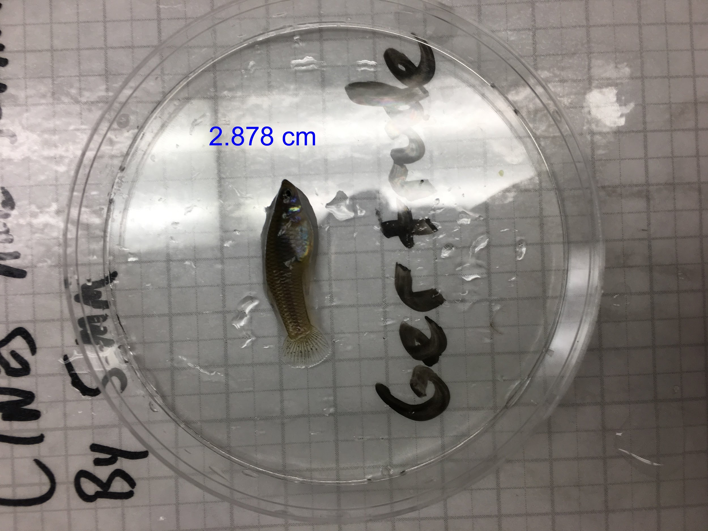

Gunther 2.552 cm, 0.20 g

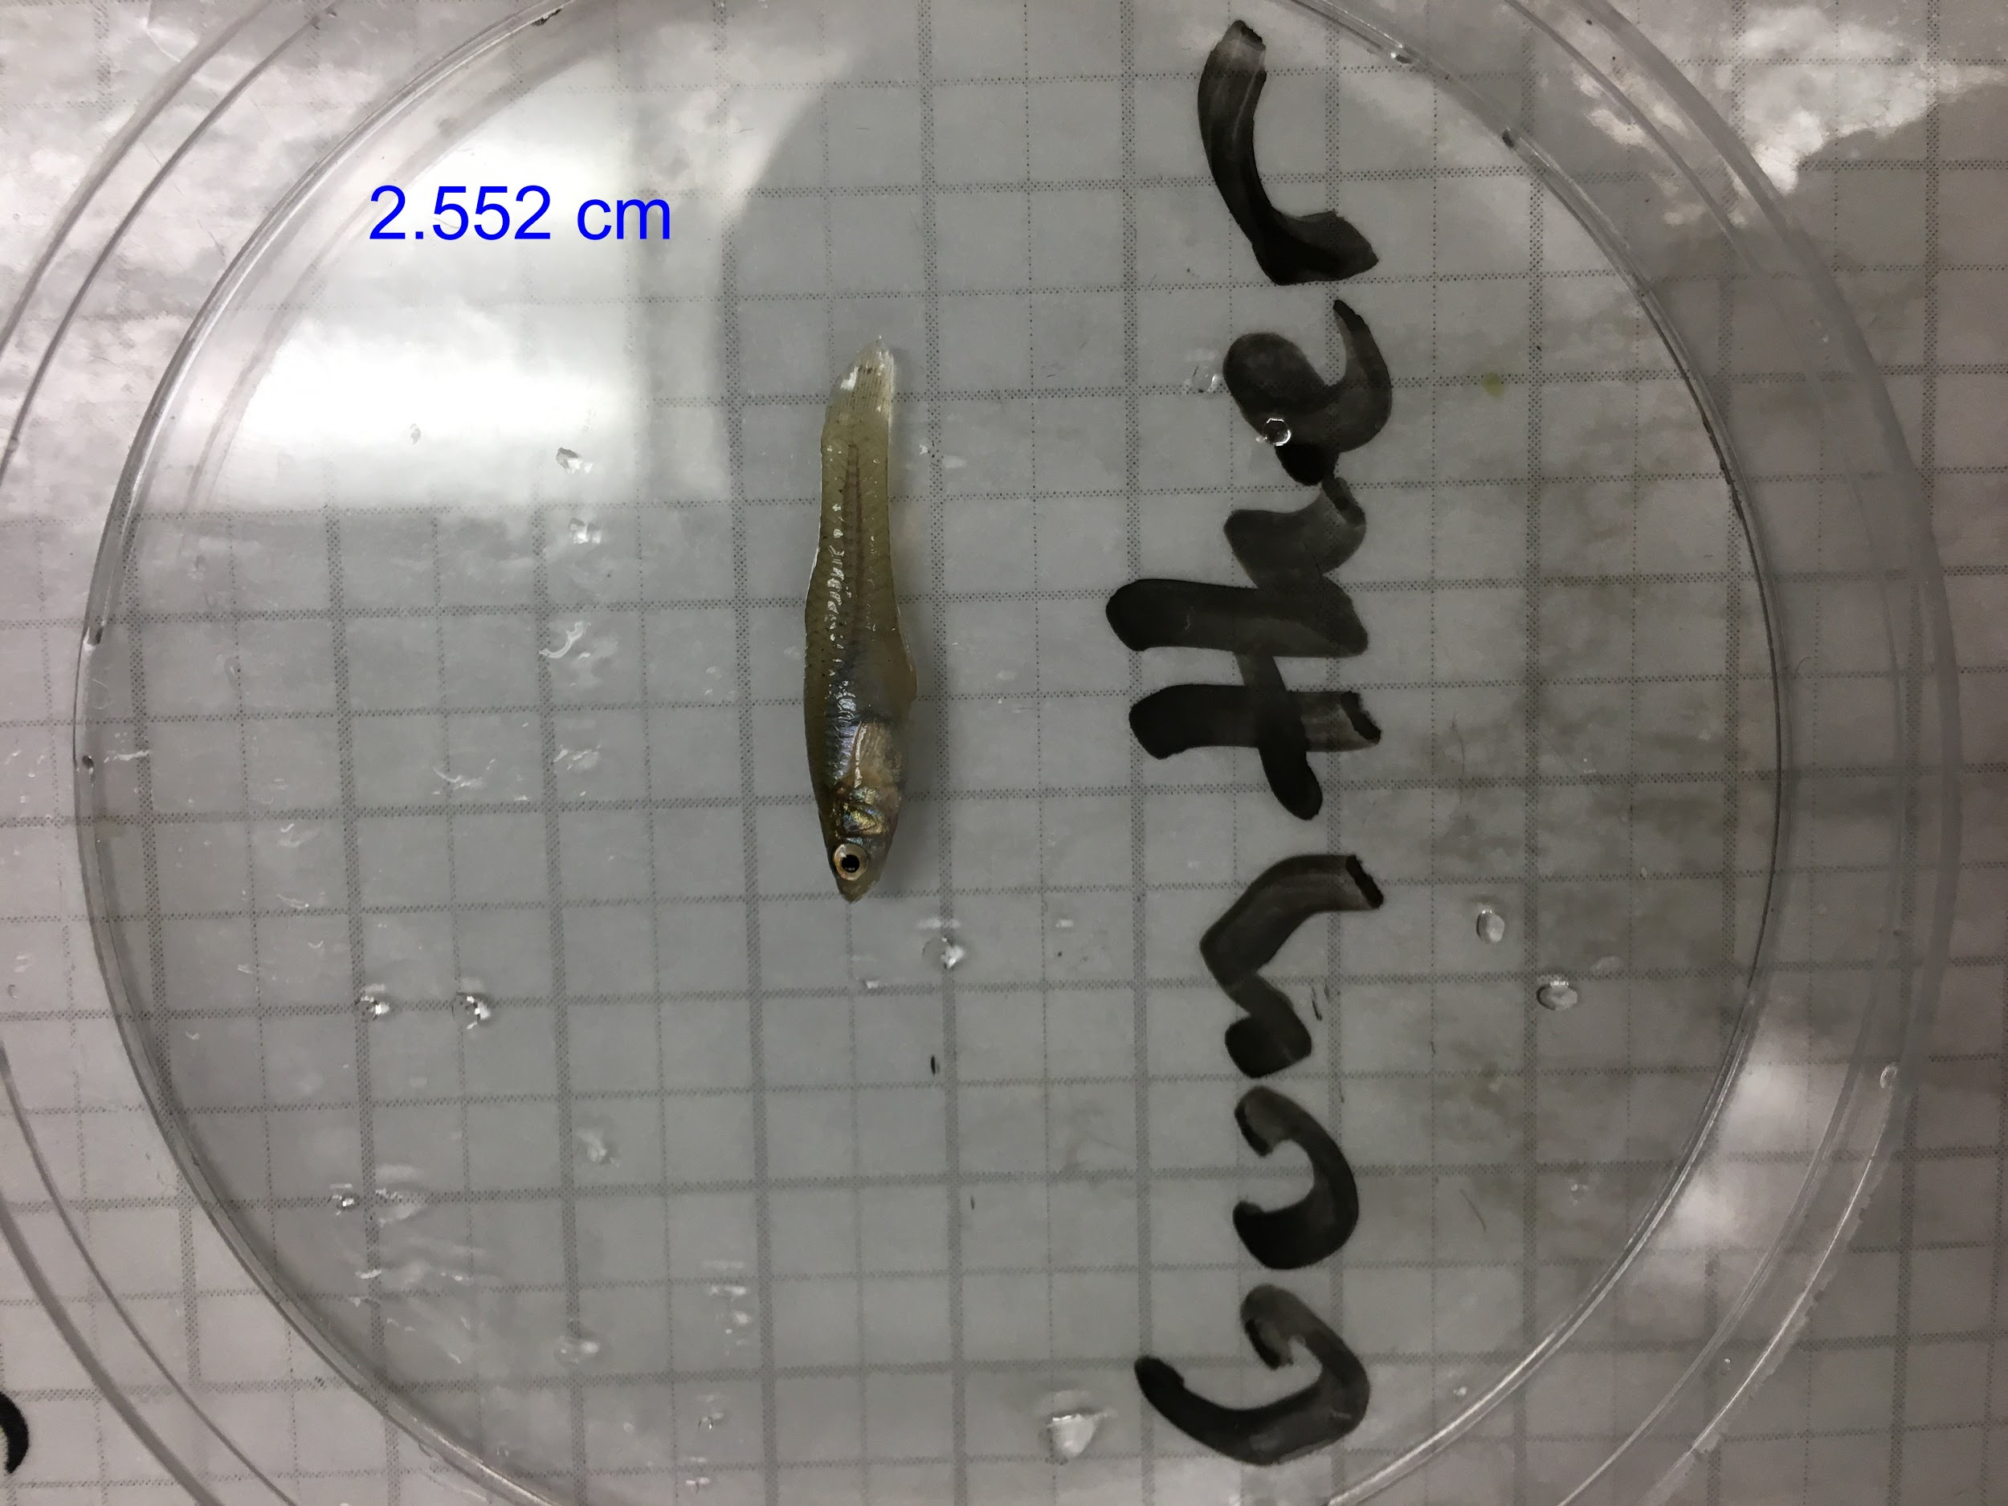

LOW

Willis 2.235 cm, 0.19 g

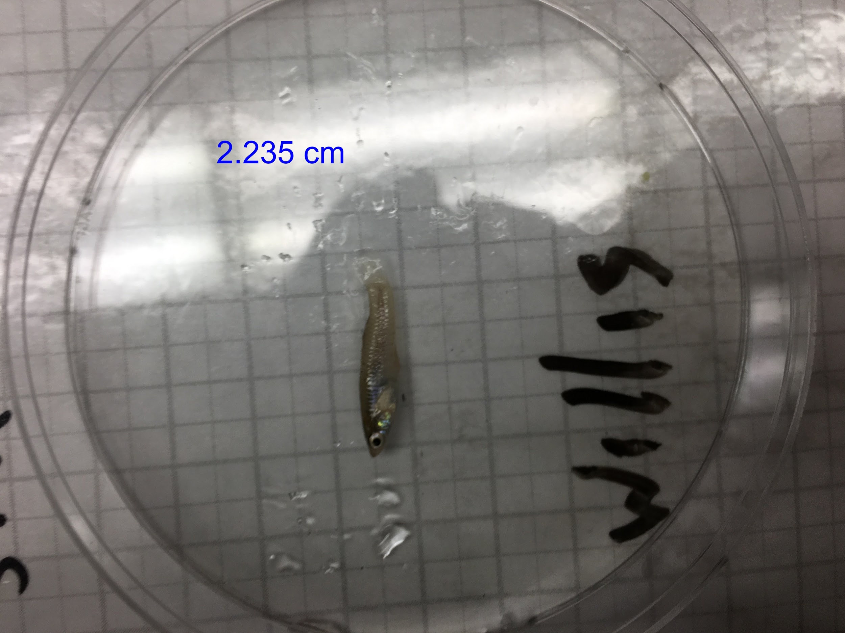

Wyatt 2.366 cm, 0.23 g

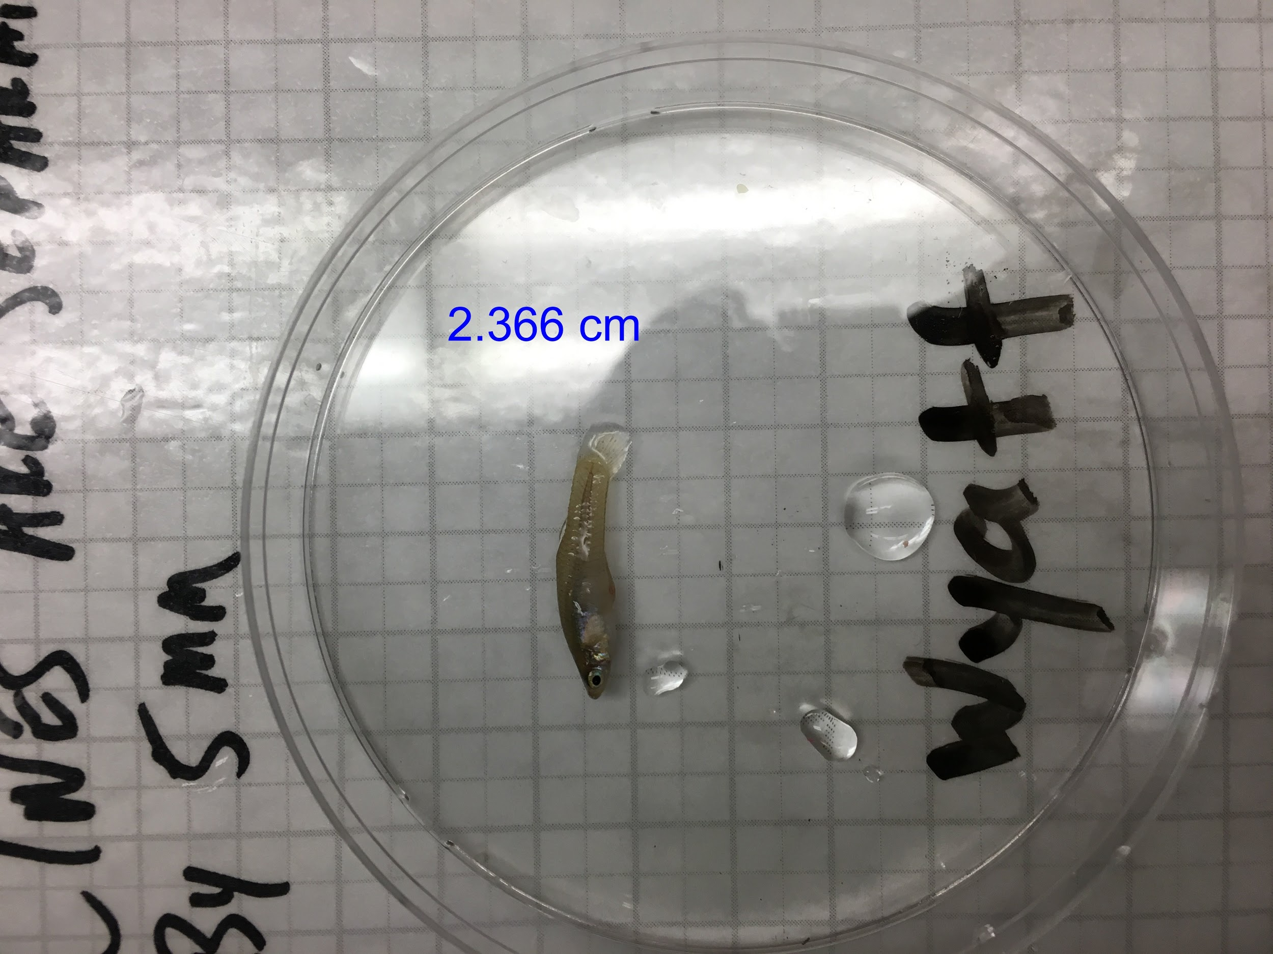

Winona 3.227 cm, 0.80 g

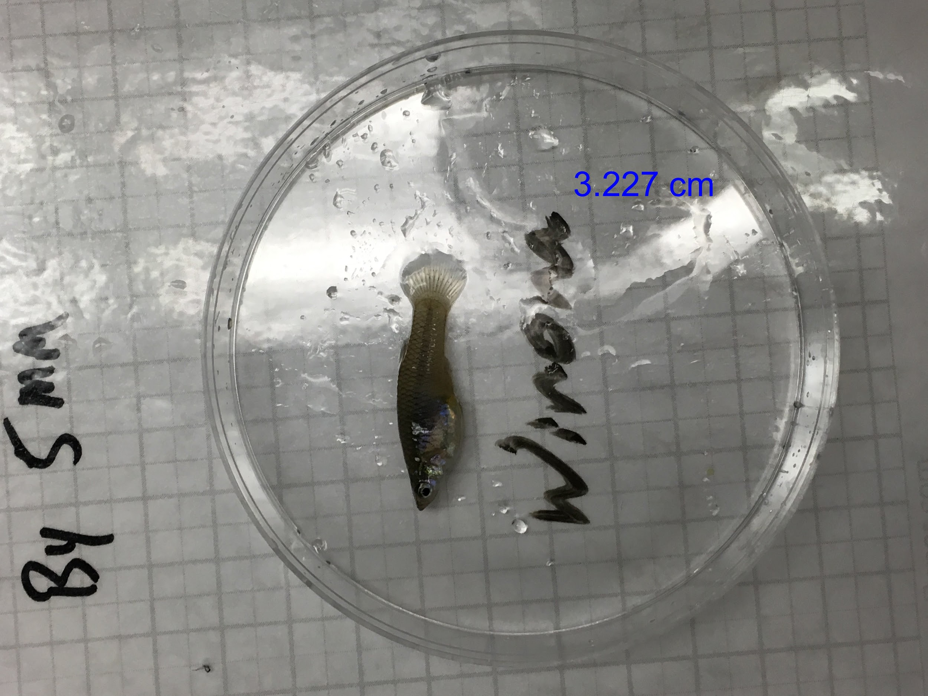

**Tasks for each day**

Top off water levels

Check one video for each tank

Make 6 food balls (2 people)

Replace food balls

Straighten feeder at the end of the day

**Assays and protocols**

**Shuttle box protocol**

1. Fill tank up to 10 cm height (approximately 1 bucket).

2. Turn on camera and ensure that tank is centered in camera view.

3. Make sure that screens are plugged into outlet and into the computer. Screens

should be turned on when the light next to the screen is green (NOT RED).

4. Put computer on “duplicate” setting (Command + P). Turn off notifications and sleep

function on both computers.

5. Put fish in the tank.

6. Change camera settings to ensure that focal fish is clearly visible and trackable.

7. Start recording and place a ruler in the tank.

8. Start each video on each computer at the same time, making sure to pull out the

ruler as soon as both videos are started.

9. The stimulus video “final1” shows the shoal first and the video “final2” shows the

shoal second.

10. Come back in an hour and stop the video and save it- use the naming scheme:

compcog_shuttlebox_CC-1_R_gail_aug_29_2017

11. **BEFORE THE NEXT FISH swirl the water 5 times clockwise and 5 times counter clockwise

NOTE- the ruler should always be on the left side of the tank. The camera flips this, but note that the left computer plugged into the left screen (the one with the camera) also has the ruler on the left.

The side is which side for Final1!

**Detour protocol**

1. Fill tank up to approximately **13cm** height (approximately 2 buckets of water).

2. Make sure the barrier is 10 cm from the end of the runway and equidistantly spaced

from either wall.

3. Lights hang on either side of the tank. When the tank is in the left direction, the light

closest to the wall hangs at an outward angle by attaching a binder clip connected to the

light by string onto the metal fringe on the wall. When the tank is in the right direction,

the light farthest from the wall is set at an outward angle by the reward by clipping it to a

metal stand.

4. Turn off autofocus on the camera.

5. Adjust camera settings to give as much contrast between the focal fish and the

background as possible.

6. A cylindrical critter carrier with a lid is filled with water and a FEMALE fish is placed in the center of the reward zone along the back wall. The same with a MALE is placed behind the UV pass glass on the blue square on the floor of the tank

7. A PVC piper is placed in the runway at its back wall.

8. The camera is started and a fish is dropped into the PVC pipe. It gets **5 minutes** to

habituate and then the PVC pipe is pulled and the trial officially begins.

9. The fish is allowed a total of 10 minutes to complete the task. If the fish finishes

before the time limit expires, it is still permitted the full 10 minutes.

*NOTE- for pilot fish got a detour using a LURE predator inspection

**Details/Misc**

Lights have the following filters on (outermost first: R4360, R365, Gamcolor 1532)

- Gamcolor 1532 is the same as Lee 203

- R365 is the same as Lee 201

4 lights around each tank, suspended from the rack above using zip ties- get height

Lux measurements (All on Auto 2000):

Pluto (multiple measurements): 57, 61, 70, 44, 57, 42

Jupiter: 55, 64, 62, 67, 56, 56

**Numerosity “Settings”**

-30 second videos taken at intervals between the trials, total of 8 taken per day (ask Richie when these are taken, also note that the first of the three comparative cognition rounds started these 30 seconds not at the very beginning of the round but around day 5)

**Habituation**

0:00- camera turns on

0:30- screen turns on

0:40- feeder drops food/empty ball

4:30- feeder pulls up food/empty ball, screen turns off, camera stops

**Training/Testing**

0:00- camera turns on

0:30- screen turns on

0:40- feeder drops food/empty ball

0:50- feeder pulls up food/empty ball

4:30- screen turns off, camera stops

**Captain’s Log**

**Round 17 (Grace)**

The other rack had teal blue felt over it so the lighting may be a bit off.

The first day of habituation the videos are short because we added 30 seconds on at the beginning but didn’t extend it by 30 seconds.

1_1 Pluto’s water too high, empty ball sitting in the water before trial, fixed

1_1 Earth’s feeder the strings got stuck so nothing went in the water, fixed

The first trial of training (3_1) the balls were dropped 8 seconds after the screens came on, which was changed to 10 seconds by 3_2

3_1 Haumea’s empty ball did not reach the water (food ball was fine)

3_2 earth’s empty ball did not reach the water (food ball was fine)

Food was a bit moldy morning of Monday 8/14 so day 8 of training for round 1, changed out

Days 6,7,8 earth’s right food ball as in the water

Days 6 7 8 haumea’s left and right screen and feeder were offset by about 4 seconds, I date reset after 8_3

6_2 haumea’s empty ball didn’t enter the water

**Round 18 (George)**

3_5 and 4_1, haumea’s food ball in the water

Night between day 3 and day 4 bubblers were not put in

Haumea’s right screen off for the first couple trials of day 10

CC-1 Gary had a notification in the corner of the left screen of the shuttlebox

Mercury did not work screen day 11, Haumea didn’t work at some point during testing.

**Round 19 (Gunther)**

Gunther jumped into Gertrude’s tank the night before they were put into numerosity